**Nem Negash**

**10/01/2021**

**CMSC 426**

**Lab 3**

**Step 3: You should see a meterpreter/payload session initiate on box A (the attacker’s box)**

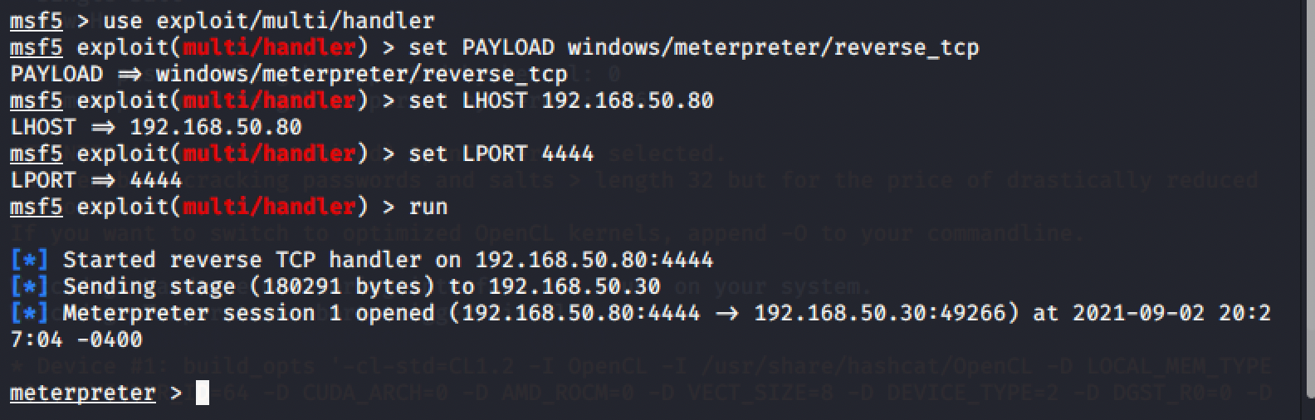

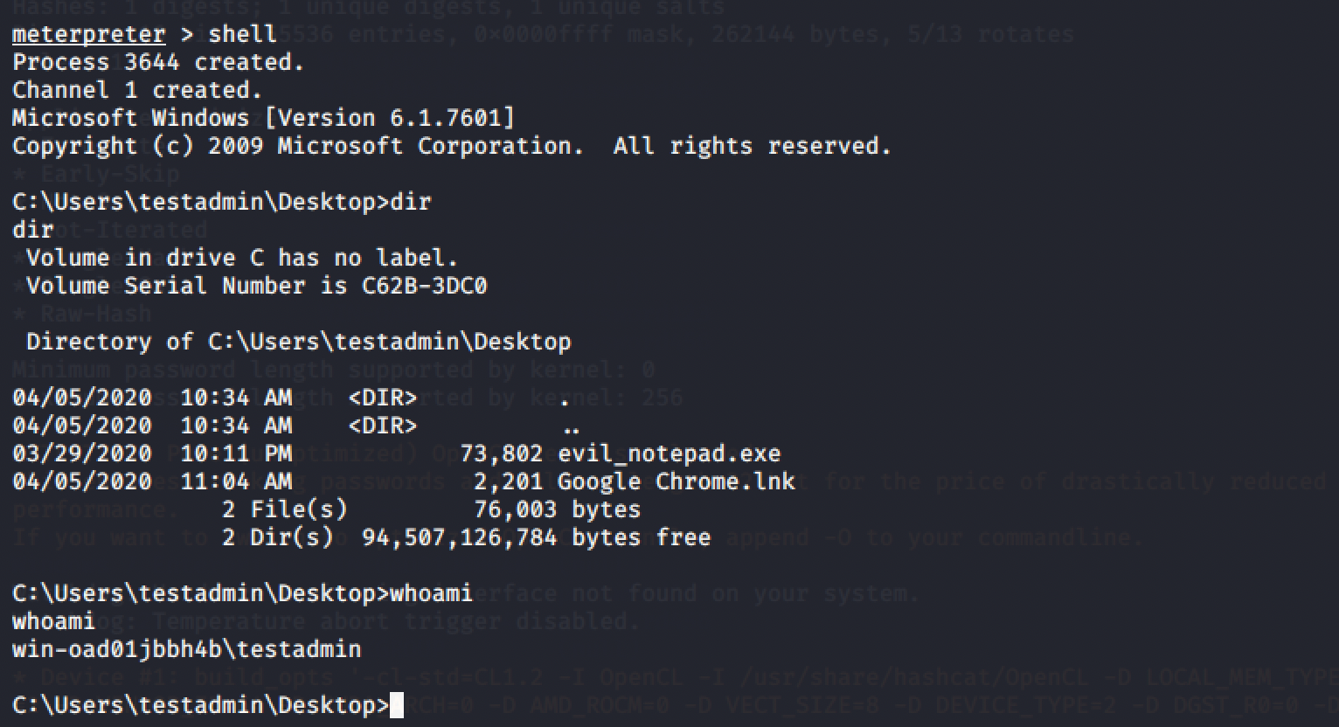

**Step 4: Enumeration with Meterpreter**

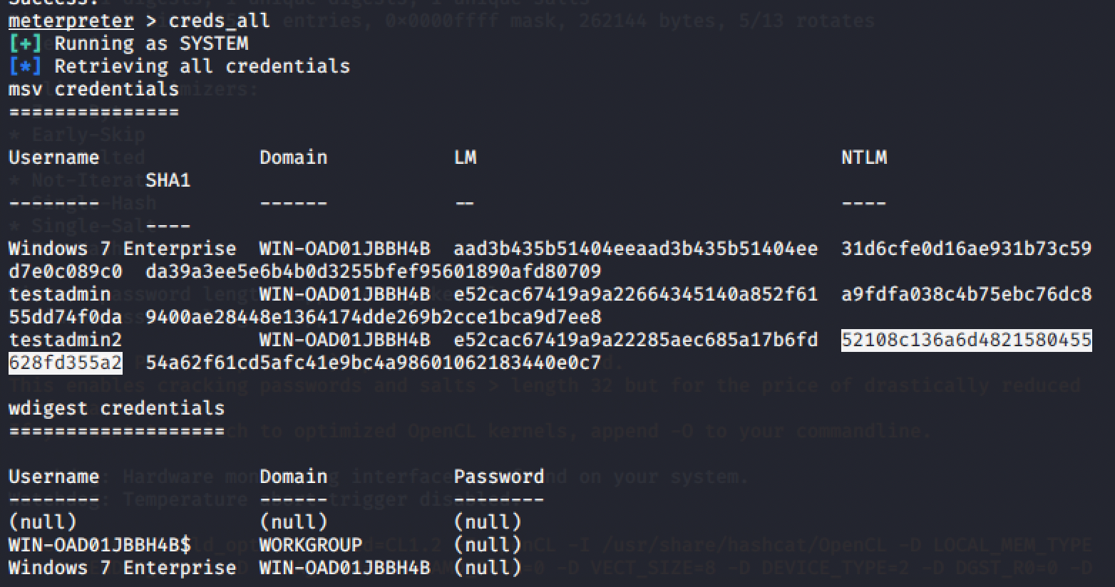

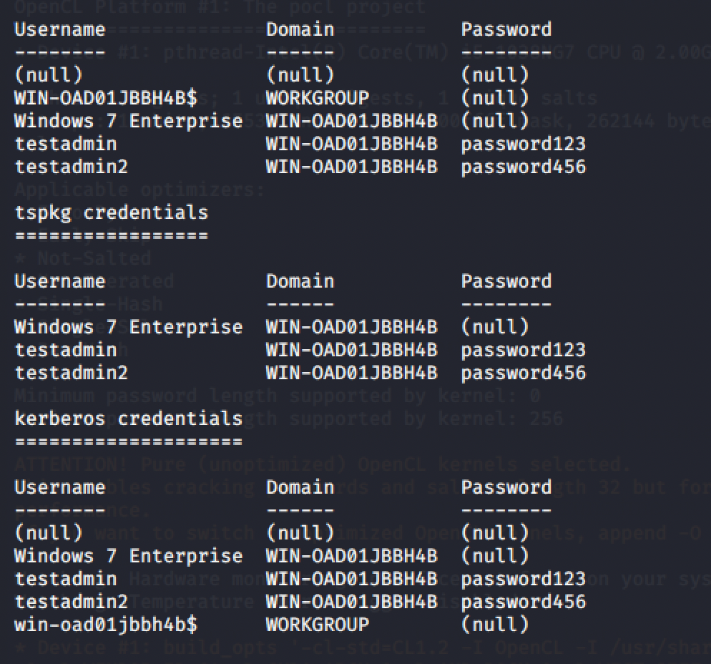

**Kept getting this error when I tried running this command:**

**hashcat -m 1000 -a 0 - - force ~/Documents/hash.txt /usr/share/wordlists/rockyou.txt**

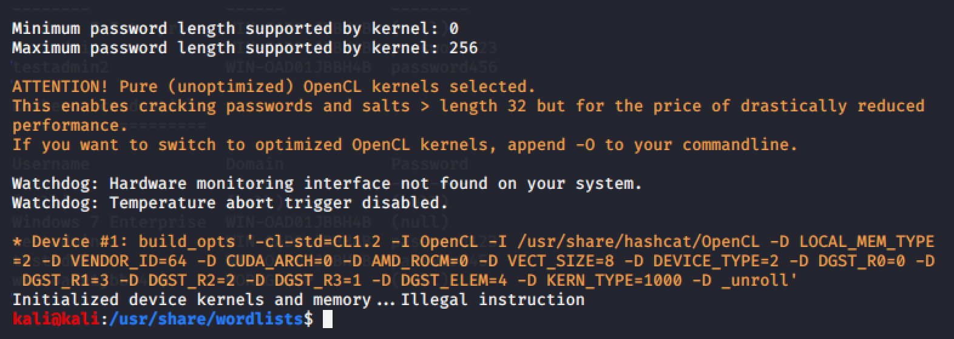

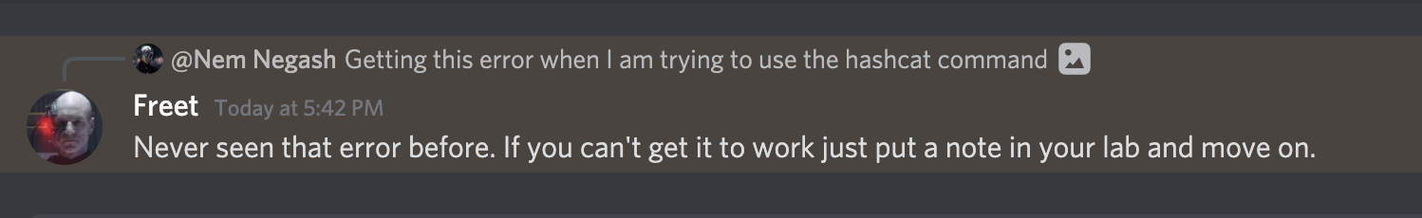

**sudo john - - wordlist=/usr/share/wordlists/rockyou.txt - - format=nt ~/Documents/hash.txt**

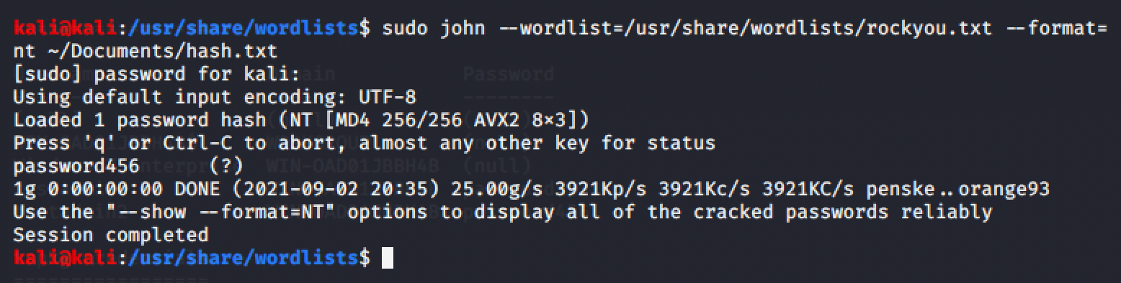

**Exercise 2 – Advanced Pillaging**

**Step 1: Enumerate Applications on the Victim Machine**

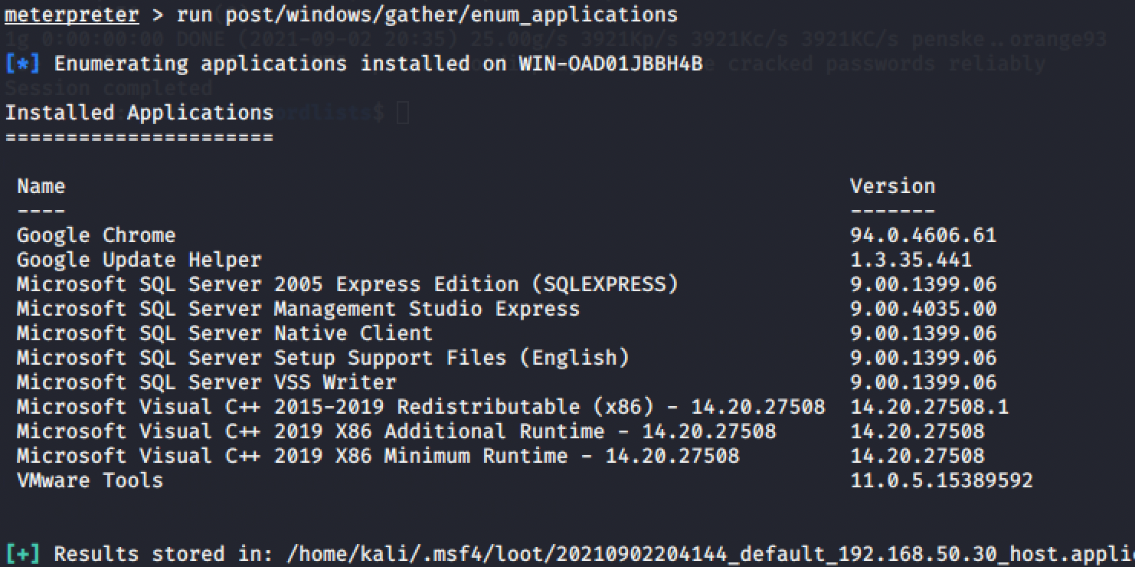

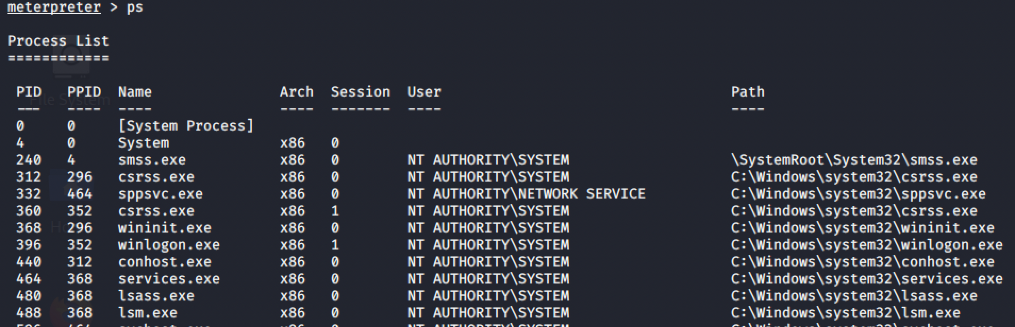





**Step 2: Monitoring Keystrokes and Obtaining Credentials**

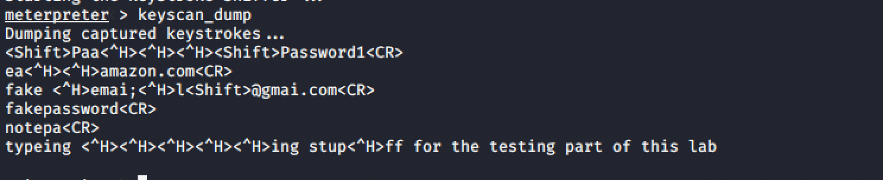

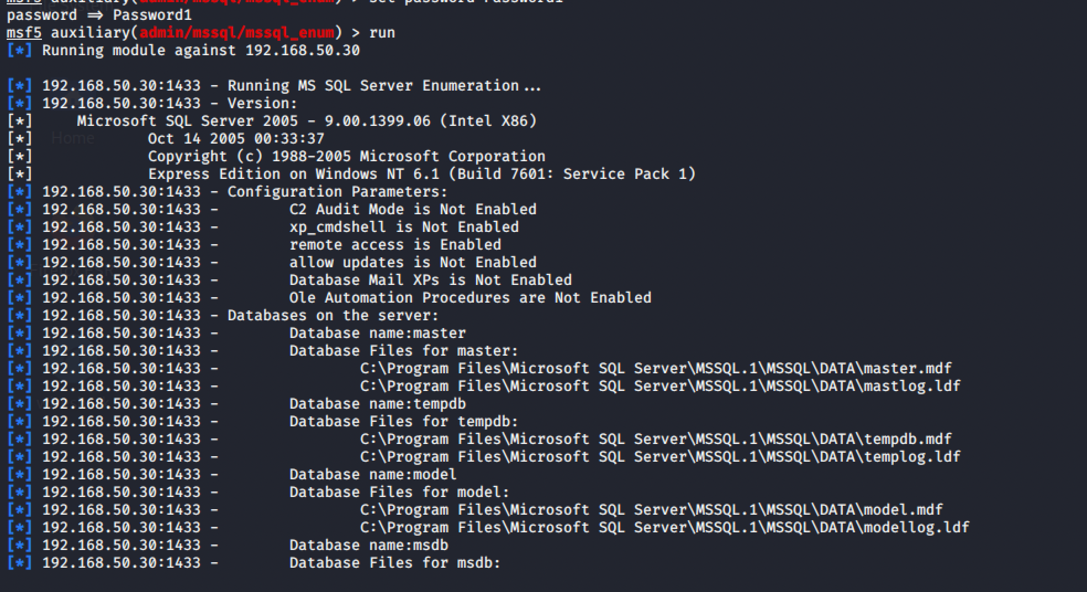

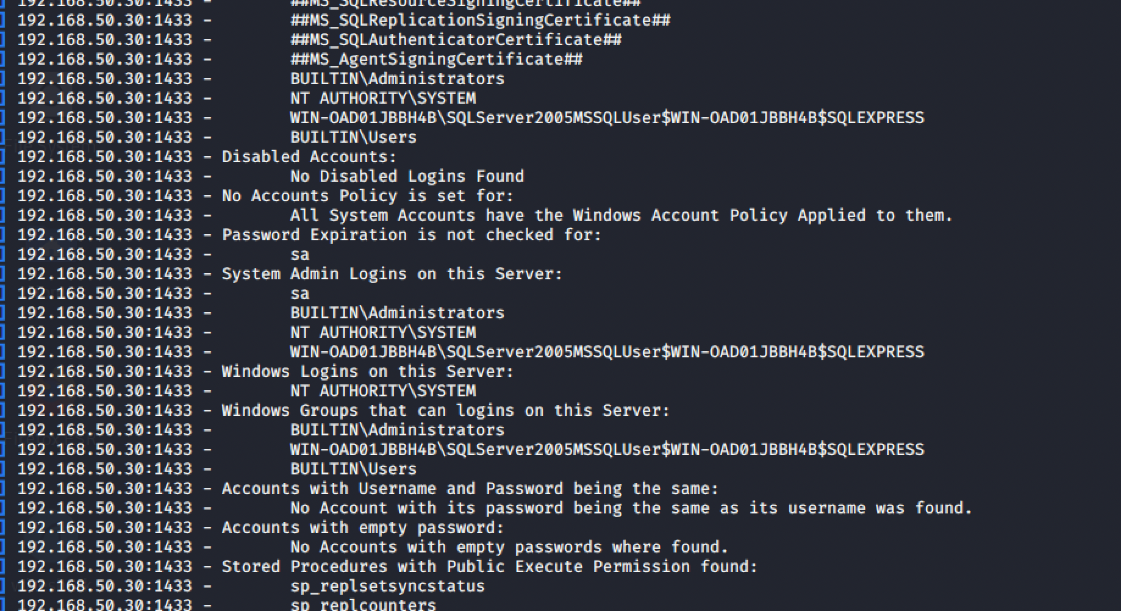

**Conclusion and Lab Report:**

1. Which of the tools/techniques used in this lab would you personally find most useful as a penetration tester?
   1. Meterpreter: This tool allows an attacker to create a reverse shell to a victim computer. This is great way to test the network security of a computer. If a user can connect using this tool it allows them to do a lot of other exploits such as key stroke logger and Mimikatz which allows the attacker to extract the credentials of a user that is already logged on. This is critical because the attacker can get credential either by reading the keystrokes on the victim computer or running the cred_all command to get the current user credentials.
2. Did these exercises make you think of other capabilities that you would find helpful for gaining user credentials on targeted systems?
   1. Brute force attack: Brute force attacks attempt account logins with as many password combinations as possible using automated tools. This includes using “dumped” or downloaded username and password combinations. Brute forcing passwords can be complex, time-consuming, and expensive from a compute standpoint and are often used by criminals as well as governments. Tools such as “Aircrack-ng" or “John The Ripper” are used for brute force attacks and can easily be found online for free.
   2. Phishing: Phishing is a social engineering attack that uses deception techniques to trick recipients into clicking on a malicious URL, typically to steal information or credentials. Phishing scams are extremely popular, and they are on the rise with more stealthy techniques that are harder to detect.
3. Who is The Flash’s secret sidekick?
   1. West, I think it supposed to be “Wally west” but the table is messed up a little